GUARDRAIL ON BRIDGE, CASE I-A
CURB HEIGHT GREATER THAN 2 INCHES

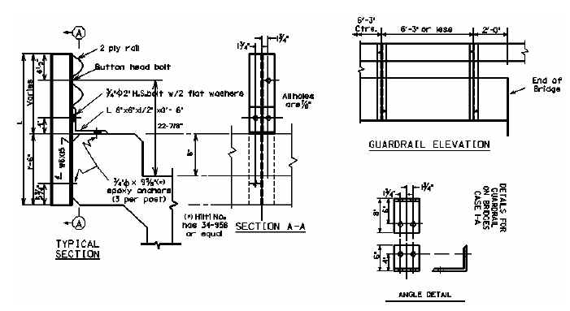
24-7/8”

Bridge MP | D = | W = | L = | No. Posts | LF of 2 PLY Rail

D = Curb Height W = Width of Bridge Curb L = Length of Guardrail Post

WARRANTS: When the dimension from the top of the existing riding surface to the top of the curb is greater than 2 inches and where the clear distance between the faces of the guardrail is less than 20 feet or the curb width is less than 12 inches, remove existing concrete and/or guardrail bridge rail and use Case I-A Bridge Guardrail.

NOTES:

- When using Case I-A Bridge Guardrail, do not pave the bridge surface flush to the top of the curb.

- When Case I-A Bridge Guardrail is used, use a Precast Concrete Bridge Block at the ends of the bridge which face opposing traffic. See detail drawing for Precast Concrete Bridge Block.

